Multiple-choice section

|  |  |  |  |  |  |  |  |  |  |
| --- | --- | --- | --- | --- | --- | --- | --- | --- | --- |
| Question | 1 | 2 | 3 | 4 | 5 | 6 | 7 | 8 | 9 |
| Answer | A | C | B | C | A | A | B | D | C |

Question 1 [7.1]

A

*n* + 5 = 12

Question 2 [7.1]

C

3*a* + 5 = 11

LHS = 3(2) + 5

LHS = 6 + 5

LHS = 11

LHS = RHS

∴ *a* = 2

Question 3 [7.2]

A

3*x* = 9

*x* = 3

Question 4 [7.2]

C

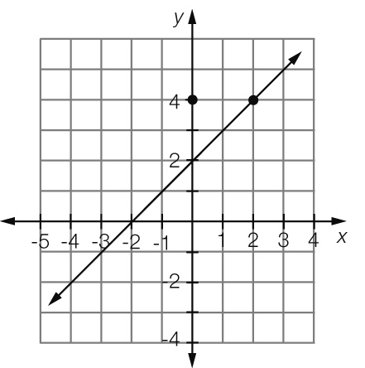

Where *x* = 2, *y* = 4

Question 5 [7.4]

A

4*x* + 4 = 3*x* + 6

4*x* − 3*x* = 6 − 4

*x* = 2

Question 6 [7.2]

B

3*b* + 1 = 16

3*b* = 16 – 1

3*b* = 15

*b* = 

*b* = 5

Question 7 [7.3]

D

2(*x* − 1) = 6

*x* − 1 =

*x* − 1 = 3

*x* = 3 + 1

*x* = 4

Question 8 [7.4]

D

5*d* + 4 = 16*d* – 7

4 + 7 = 16*d* – 5*d*

11*d* = 11

*d* =

*d* = 1

Question 9 [7.5]

B

Let *c* be the cost of one pen.

10 – 3*c* = 6.40

3*c* = 10 – 6.4

3*c* = 3.6

*c* = 

*c* = 1.2

Therefore one pen costs $1.20.

Multiple-choice total marks: 9

Short answer section

Question 10 1 mark [7.3]

Sara’s working  
 − 1 = 15  
  = 16



Question 11 1 mark [7.2]

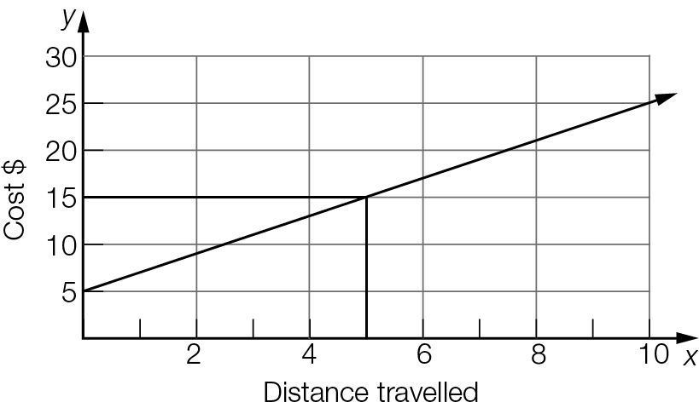

It would cost $15 to travel 5 km.

Question 12 1 mark [7.1]

*n* + 3 = 7

Question 13 2 marks [7.1]

= 20 (*x* = 4)

LHS = 

≠ RHS

Thus *x* = 4 is *not* a solution.

Question 14 1 mark [7.1]

*R* = 2*B* − 5

Question 15 4 marks [7.2]

(a) *y* = -3 (b) *y* = 5

(c) *x* = 2 (d) *x* = 0

Question 16 4 marks [7.3]

(a) − 5 = 3  
= 3 + 5  
= 8  
*a* = 16

(b) = 2  
*b* + 3 = 10  
*b* = 7

Question 17 3 marks [7.2]

(a) Let *c* be the cost of a sandwich.  
5*c* + 2 × 3 = 23.5

5*c* + 6 = 23.5

(b) 5*c* + 6 = 23.5  
5*c* = 23.5 – 6  
5*c* = 17.5  
*c* =   
*c* = 3.5  
So a sandwich costs $3.50.

Question 18 3 marks [7.3]

4(3*x* + 2) = 20

4 × 3*x* + 4 × 2 = 20

12*x* + 8 = 20

12*x* = 20 − 8

12*x* = 12

*x* = 1

Question 19 6 marks [7.2]

(a) 3*n* + 1 = 10  
3*n* = 10 − 1  
3*n* = 9  
*n* =   
*n* = 3  
Thus the number is 3.

(b) 2*n* − 6 = 8  
2*n* = 8 + 6  
2*n* = 14  
*n* =   
*n* = 7  
Thus the number is 7.

Question 20 2 marks [7.4]

3*x* + 8 = 5*x +* 4

8 – 4 = 5*x* – 3*x*

4 = 2*x*

*x* = 2

Question 21 3 marks [7.4]

3*x* + 3 = *x* + 11

3*x* − *x* + 3 = 11

2*x* + 3 = 11

2*x* = 11 – 3

2*x* = 8

*x* = 8 2

*x* = 4

Question 22 3 marks [7.4]

2 − *x* = *x*

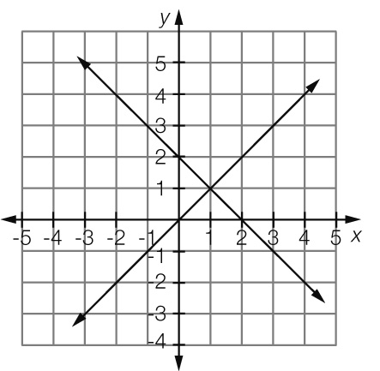

*x* = 1

Short answer total marks: 34

Extended answer section

Question 23 7 marks [7.3, 7.4, 7.5]

(a)

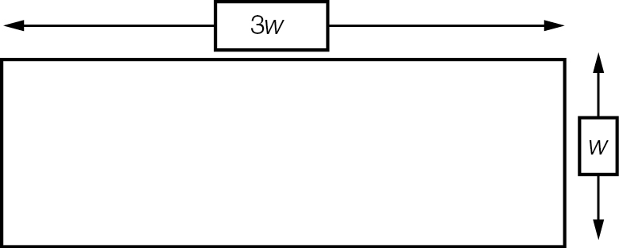

(b) *P* = 3*w* + *w* + 3*w* + *w*= 8*w*

(c) 32 = 8*w  
w* =   
*w* = 4  
Thus the width is 4 m and the length is 3 × 4 = 12 m

(d) Number of tiles = 3200cm ÷ 20cm = 160 tiles  
Total cost = 160 tiles × $0.50 = $80

Extended answer total marks: 7

TOTAL test marks: 50